Architecture and Engineering Specifications

Wisenet SKY

Cloud Video Management System

Specification Division 28 23 00



Wisenet SKY, Hanwha Techwin America   
500 Frank W. Burr Blvd.

Suite 43

Teaneck, NJ 07666

877-213-1222

www.HanwhaSecurity.com, www.WisenetSKY.com

© 2020 Wisenet SKY. All rights reserved.

**Specifications**

This Architectural and Engineering Specifications document utilizes MasterFormat™ Titles and Numbers April 2016 Edition and SectionFormat™/PageFormat™ December 2009 Edition standards by the Construction Specifications Institute (CSI).

This document specifies the architectural/engineering and bid criteria for a cloud-based security camera video management system (Cloud VMS) software

**Sections**

This specifications document contains three sections:

SECTION 28 23 00 – CLOUD SECURITY CAMERA VIDEO MANAGEMENT SYSTEM, page 3

SECTION 28 23 11.16 – VIDEO APPLIANCES, page 44

SECTION_28_23_13 – IP CAMERAS, page 51

SECTION 28 23 33.15 – MANAGED POE SWITCHES, page 61

SECTION 28 23 33.20 – MANAGED POE SWITCHES, page 65

**Notes to Specifier**

1. Where several alternative parameters or specifications exist, or where the Specifier has the option of inserting text, such choices are presented in **bold red text** or in bracketed red text such as [this] **OR** [that].
2. Explanatory notes and comments are presented in red hidden text (a Microsoft® Word® feature).
3. Delete any item or paragraph that is not applicable to this project, renumber the paragraphs. Insert additional provisions as required for this project.
4. Comments are used to show added or revised content.
5. Delete the Notes to Specifier and remove inserted comments before releasing this document.

**Document Disclaimer and Restrictions**

Information in this document was current as of the time of publication, and subject to change without notice, Inc. For the most up-to-date information, visit www.hanwhasecurity.com.

Section 28 23 00

Cloud Video Management System

[**Specifier Note:** Deleted unused optional items in red.]

1. General
   1. Summary
      1. The section specifies requirements for the provision of all equipment, materials, labor, documentation, and services necessary to furnish and install a complete and operational integrated Cloud Security Camera Video Management System (Cloud VMS) for the project, which supports an unlimited number of users, cameras, servers, and sites.
      2. System equipment and installation shall comply with all provisions and requirements of this specification as well as all applicable national, state and local codes and standards.
      3. Products [Furnished] **or** [Supplied] But Not Installed Under This Section.

[**SPECIFIER NOTE:** Delete this Article B if not used. Replace “Furnished **[or]** Supplied” with either “Furnished” or “Supplied”, as which word to use is a matter of preference. Briefly, list products that are only furnished/supplied by this section, but whose installation is specified in other sections. For example, these may be new products “installed by the owner”.]

* + 1. Products Installed But Not [Furnished] **or** [Supplied] Under This Section.

[**SPECIFIER NOTE:** Delete Article this C if not used. “Replace Furnished **[or]** Supplied” with either “Furnished” or “Supplied”, as which word to use is a matter of preference. Briefly, list products that are only installed by this section, but furnished/installed under other sections. For example, these may be new products “furnished by owner”, or existing cameras that have previously been installed.]

* + 1. Related Requirements:

[**SPECIFIER NOTE:** **Delete any item or paragraph not applicable in this Article D.** The purpose of Related Requirements is to briefly list other documents or sections in the Project Manual that are related to, and/or dependent on, the work results or information specified elsewhere. The list should be limited to documents or sections with specific information that the reader might expect to find in this document, but is specified elsewhere (i.e. in a separate Project document).]

* + - 1. Section 27 00 00 Communications (Division 27)
         1. Section 27 05 00 Common Work Results for Communications   
            [**SPECIFIER NOTE:** For general requirements that are common to more than one section in Division 27.]

Section 27 05 28 – Pathways for Communication Systems

* + - * 1. Section 27 10 00 – Structured Cabling

Section 27 13 00 – Communications Backbone Cabling

* + - * 1. Section 27 15 00 – Communications Horizontal Cabling
      1. Section 28 00 00 Electronic Safety and Security (Division 28)
         1. Section 28 05 00 - Common Work Results for Electronic Safety and Security. [**SPECIFIER NOTE:** For general requirements that are common to more than one section in Division 28.]
         2. Section 28 08 00 Commissioning of Electronic Safety and Security.   
            [**SPECIFIER NOTE:** For expanded requirements for commissioning, systems readiness checklists, and training.]

28 08 11 Testing for Baseline Performance Criteria

* 1. References
     1. Abbreviations and Acronyms:
        1. AES: Advanced Encryption Standard.
        2. API: Application Programming Interface.
        3. CamLAN: Camera LAN
        4. CE: Conformity for Europe.
        5. CMVR: Cloud Managed Video Recorder
        6. DES: Data Encryption Standard.
        7. DVI: Digital Video Interface.
        8. FOV: Field of View.
        9. FPS: Frames per Second.
        10. FULL HD: High Definition video resolution of 1920 x 1080 pixels
        11. GB: Gigabyte.
        12. GigE: Gigabit Ethernet.
        13. H.264: Video Codec.
        14. HD: High Definition video resolution of 1280 x 720 pixels
        15. HD2: Full HD video resolution of 1920 by 1080 pixels
        16. HDMI: High-Definition Multimedia Interface
        17. HTTPS: HyperText Transfer Protocol Secure.
        18. JPEG: Joint Photographic Experts Group.
        19. LAN: Local Area Network.
        20. NIST: National Institute for Standards and Technology
        21. NVR: Network Video Recorder.
        22. OS: Operating System.
        23. PDF: Portable Document Format.
        24. PoE: Power over Ethernet.
        25. PTZ: Pan-tilt-zoom.
        26. RAID: Redundant Array of Independent Disks.
        27. REST: Representational State Transfer.
        28. SaaS: Software as a Service.
        29. SD: Standard Definition video resolution of 640 x 480 pixels.
        30. SSN: Secure Service Network.
        31. SVG: Scalable Vector Graphics.
        32. TB: Terabyte.
        33. TCP/IP: Transmission Control Protocol/Internet Protocol.
        34. UPnP: Universal Plug and Play.
        35. USB: Universal Serial Bus.
        36. VMS: Video Management System.
        37. VSaaS: Video Surveillance-as-a-Service.
        38. WAN: Wide Area Network.
     2. Definitions:
        1. *2CIF:* 2xCIF resolution (640x240).
        2. *4CIF:* 4xCIF resolution (640x480).
        3. *Access Control:* A function or a system that restricts access to authorized persons only.
        4. *API:* Application Programming Interface, a set of clearly defined methods of communication between various software components.
        5. *Authentication:* A process that establishes the origin of information, or determines an entity’s identity.
        6. *Authorization:* A process that associates permission to access a resource or asset with a person and the person’s identifier(s) for the purpose of granting or denying access.
        7. *Bridge:* Cloud-managed on-premise appliance that receives and buffers video, audio, alarm and event data from cameras and video encoders, and sends it to the Cloud VMS in the cloud data center. The Bridge “bridges" between the cloud data center and the on-site cameras.
        8. *CIF:* Common Intermediate Format resolution (320x240).
        9. *Camera LAN:* A Local Area Network dedicated to security video cameras.
        10. *Camera System:* The entire system for using security cameras. It includes the cloud-based Video Management System software, any Bridge or Cloud-Managed Video Recorder appliances, and any network switches that may be used to connect cameras to them.
        11. *Cloud-Managed Video Recorder (CMVR):* Cloud-managed on-premise appliance that performs all the video functions of a Bridge (see *Bridge* above), plus locally stores video on-premises.
        12. *Contractor:*  Contractor refers to the firm selected by the Owner and any of the Contractor’s subcontractors, vendors, suppliers or fabricators, to perform work specified in these contract documents and supporting documentation. The contractor shall supply all equipment, labor, material, and services necessary to complete the project construction in accordance with Contract Documents.
        13. *Local Display:* Display of live video on a video monitor that is connected directly to a Bridge or Recorder.
        14. *Motion area:* The name of an area within a camera’s video image that has been defined as a Region of Interest, and to which motion detection settings have been established, to enable recording on motion, and to trigger alerts or notifications.
        15. *Multi-site:* Reference to a Cloud VMS system that spans multiple physical facility locations.
        16. *Multitenancy.* For VSaaS applications, different customers (subscribers) share the same application and database but can only access their data and video devices. To each subscriber, it appears as though the subscriber’s registered users are the only application users.
        17. *ONVIF:* Open Network Video Interface Forum, a global and open industry forum for the creation of standards for how IP-networked products within video surveillance and other physical security areas can communicate with each other.
        18. *Power over Ethernet:* Technology for passing low-voltage electric power along with data on twisted pair Ethernet network cabling, commonly used to provide power to network cameras and other types of networked devices.
        19. *Region of Interest:* An area within the field of view of a camera that contains the activity to be monitored and/or recorded. A region of interest is outlined to define a Motion Area.
        20. *Reseller:* A contractor authorized by the manufacturer to furnish, install and maintain manufacturer’s Cloud VMS and video appliances, who may be the primary contractor or a subcontractor for the provision of this project’s Cloud VMS system.
        21. *REST:* Representational State Transfer (REST) is a software architecture style consisting of guidelines and best practices for creating scalable web services.
        22. *RESTful API:* Web service API that adheres to the REST architectural constraints.
        23. *System Meta-Data:* System meta-data
        24. *True Cloud System:* A cloud application that is engineered to provide cloud-only features and benefits through the utilization of five key characteristics of cloud computing defined by NIST SP-145 and ISO/IEC 17788, which are *on-demand self-service, broad network access, resource pooling, rapid elasticity, measured service*, and a sixth key characteristic defined by ISO/IEC 17788, *multitenancy*.
        25. *Universal Plug and Play (UPnP):* Set of networking protocols that permit networked devices, such as personal computers, printers, Internet gateways, Wi-Fi access points, IP video cameras, and mobile devices to seamlessly discover each other's presence on the network and establish functional network services for data sharing and communications.
        26. *Video Metadata:* Metadata means “data about data”. Video metadata is data about a video stream, such as points in time when motion occurred within the video scene, an object was detected, or when an alarm was activated, such as a camera tamper alarm.
  2. Submittals
     1. Submit under provisions of Section 01 30 00 - Administrative Requirements.
     2. Product Data: Manufacturer's data sheets on each product to be used, including:
        1. Preparation instructions and recommendations.
        2. Storage and handling requirements and recommendations.
        3. Installation methods.
     3. Shop Drawings: Provide the following shop drawings:
        1. Device location drawings.
        2. Logical system block diagram.
  3. CLOSEOUT SUBMITTALS
     1. Maintenance Contracts:
        1. Submit the contractor’s maintenance service agreement for the Owner’s review that includes cost and services for two years.
     2. Warranty Documentation:
        1. Submit manufacturer’s standard warranty for the video management system.
  4. References and Code REquirements
     1. The system shall be installed in accordance with all applicable national, state, provincial, regional and local codes and standards. All equipment shall be U.L. listed or meet U.L. requirements for its intended use.
  5. COMPLETION
     1. The contractor shall substantially complete Cloud VMS installation by the target date established by the Owner.
  6. Quality assurance
     1. Install and test Cloud VMS appliances, camera network and an appliance Internet connection(s).
     2. Qualifications:
        1. Manufacturers:
           1. The manufacturer shall regularly and presently produce, as one of the manufacturer's principal products, the equipment, services, and material specified for this project.
        2. Contractors/Installers: The contractor or security sub-contractors shall comply with the following requirements.
           1. Be licensed to perform security installations in the state in which the work is to be performed.
           2. Have a minimum of five (5) years’ experience installing and servicing systems of similar scope and complexity**.**
           3. Provide four current client references for systems of similar scope and complexity which became operational in the past three years**.**

At least three references shall utilize the same system components, in a similar configuration, as a proposed system.

References shall include a current point of contact, company or agency name, address, telephone number, complete system description, date of completion, and the approximate cost of the project. The owner reserves the option to visit the reference sites, with the site owner’s permission and representative, to verify the quality of installation and the reference’s level of satisfaction with the system.

* + - * 1. Utilize only factory-authorized technicians to install, program, and service Cloud VMS appliances**.**
        2. Provide copies of system manufacturer certification for all technicians**.**
        3. Ensure technicians have a minimum of five continuous years of technical experience in electronic security systems**.**
        4. Provide evidence that installing a service company is an authorized dealer in good standing for the product’s manufacturer, and that company meets the manufacturer’s technical certification requirements.
  1. Product Standards
     1. Provide at the time of installation, the latest version of all equipment and software.
        1. Discontinued equipment shall not be acceptable.
  2. Delivery, storage, and handling
     1. Video Appliances:
        1. Store in temperature- and the humidity-controlled environment in the manufacturer's original sealed containers. Maintain ambient temperature between 50 and 85 Degrees Fahrenheit and not more than 80 percent relative humidity, non-condensing.
        2. Open each container; verify contents against packing list, and file a copy of packing list, complete with container identification for inclusion in operation and maintenance data.
        3. Save original manufacturer's containers and packing materials and deliver as directed under provisions covering extra materials.
  3. Site conditions
     1. Ambient Conditions:

[**SPECIFIER NOTE:** Identify site-specific ambient conditions under which work must be performed such as bad lighting, obstacles, or extreme cold/heat that installers or equipment may have to deal with. Delete if not needed.]

* + 1. Existing Conditions:

[**SPECIFIER NOTE:** Identify site-specific existing conditions. Such as the condition of existing work subject to reworking or modification.]

* 1. Warranty
     1. Manufacturer Warranty:
        1. The manufacturer shall warrant that software and hardware products are free from defects in materials and/or workmanship for one year from the date of shipment.
        2. During the warranty period, the manufacturer shall provide periodic updates.
     2. Special Warranty:
        1. Maintenance and Service:
           1. General Requirements

The contractor shall warrant from the final acceptance date agreed by Owner that all equipment and labor provided for Cloud VMS installation will, under normal use and service, be free from defects and faulty workmanship as stated below.

The warranty period shall be one year from the final acceptance date or match the manufacturer's warranty, whichever is greater.

* + - * 1. Description of Work:

Deployment of Cloud VMS includes installation and setup of Cloud VMS appliances, plus any new and existing equipment specified in Article 2.1. OWNER-FURNISHED PRODUCTS.

* + - * 1. Personnel:

Service personnel shall be certified in the maintenance and repair of the selected type of equipment and integrations and qualified to accomplish all work promptly and satisfactorily.

* + - * 1. Schedule of Work:

Work shall be performed during regular working hours, Monday through Friday, excluding federal holidays.

* + - * 1. Emergency Service:

The owner shall initiate service calls whenever the system is not functioning properly.

Provide Owner with an emergency service center telephone number. The emergency service center shall be staffed 24 hours a day, 365 days a year. Owner shall have sole authority for determining catastrophic and non-catastrophic system failures within parameters stated in General Project Requirements.

Catastrophic system failures are defined as any system failure that Owner determines will place a project facility at unacceptable security risk.

For catastrophic system failures, Contractor shall provide same-day four (4) hour service response, with a defect correction time not to exceed eight (8) hours from [notification] [arrival on site].

For non-catastrophic failures, Contractor shall provide service response within eight normal business (8) hours with, a defect correction time not to exceed 24 hours from notification.

* + - * 1. Operation:

Scheduled or requested adjustments and repair shall include verification of corrected system operation as demonstrated by documented performance verification testing.

* 1. Licensing
     1. Licensing for product installation shall be provided by manufacturer for a period of one (1) year from date of substantial completion.
  2. distribution
     1. System shall be offered commercially through authorized resellers who will install its video appliances on customer premises and connect the customer’s existing cameras to the system or install new cameras. Reseller shall perform initial camera programming and user set-up and thereafter monitor customer account through Reseller’s Dashboard described herein.

1. Products
   1. Owner-furnished products   
      [**SPECIFIER NOTE:** use this article to describe owner-furnished products to enable the contractor to install them correctly, or to ensure compatibility or proper system operation. delete if not applicable.]
      1. New Products:
         1. <list new products furnished by owner>.
      2. Existing Products:
         1. <list existing products/systems furnished by owner, such as existing cameras, computers and network infrastructure>.
   2. SYSTEMS

[**SPECIFIER NOTE:** The following articles describe equipment and services that may be used in a Cloud VMS project. Add, modify or delete as required.]

* + 1. Manufacturer:
       1. Wisenet SKY, Hanwha Techwin America , 500 Frank W. Burr Blvd., Suite 43, Teaneck, NJ 07666
          1. Telephone: (877) 213-1222
          2. Website: www.HanwhaSecurity.com, www.WisenetSKY.com
       2. Substitution Limitations: No Substitutions.
    2. Cloud Security Camera Video Management System (Cloud VMS):

[**SPECIFIER NOTE:** The following subparagraphs describe equipment and services that may be used in a Cloud VMS project. Add, modify or delete as required.]

* + - 1. *Description:* Cloud-based video surveillance as a service (VSaaS) solution for video management and long-term video storage, supporting an unlimited number of users, cameras, servers and sites, with a browser-based video management system application (web app) and mobile device applications (mobile apps) for iOS and Android devices.
      2. System Architecture:
         1. *Purpose-Built Secure On-Premise Video Appliances:*

*Bridges*, for receiving and buffering video, audio, alarm and event data from cameras and video encoders, and sending it to the Wisenet SKY cloud data center.

*Cloud-Managed Video Recorders (CMVRs)*, referred to in this document simply as Recorders, which perform all the Bridge functions plus locally store video on-premises.

* + - * 1. *On-Premise Ethernet Networks:*

*Camera Network.* Local network for security cameras, automatically established by video appliances. Networking, routing and firewall functionality built into appliances to ensure integrity of appliances and camera networks.

*Owner-Provided Internet Connection.* Internet connection provided by customer’s Internet Service Provider (ISP).

* + - * 1. *Secure Cloud Data Center:*

*Application servers:*

Video management system application platform.

Video API platform.

*Data Storage:*

System data storage.

Video data storage.

* + - * 1. *Video Management System Applications:*

*Web App:* Browser-based web applications.

*Mobile Apps:* Smart mobile device iOS and Android native applications.

* + 1. Performance/Design Criteria:
       1. *True Cloud Application:* Provide features and capabilities that utilize the six essential characteristics of cloud computing.
          1. *Video Retention Period Assurance:* Provide the following options for selecting the number of days or years for video retention, and automatically expand or reduce video storage to provide the storage space required: 7, 14, 30, 60, 90, 180, 1 Year, or 2 Years. (Cloud computing characteristics: On-demand service, resource pooling, rapid elasticity, measured service.)
          2. *Broad Network Access:* Provideaccess to the Cloud VMS application, for users and for camera systems, via common commercial broadband Internet connections from any Internet-accessible geographical location. (Cloud computing characteristic: broad network access.)
          3. *Multitenancy:* For eachgeographical region served by a Cloud VMS data center, provide a single Cloud VMS application that utilizes resource segregation and isolation to assure that the system resource assets and data from one subscriber account cannot be accessed or modified via a different account. (Cloud computing characteristic: multitenancy.)
       2. *Languages:* Web browser and web application will provide translation, via user profile selection, into the following languages:
          1. *English, Japanese, Dutch, Spanish, French, Italian, Polish, Turkish*
       3. *Video Encoding:* Provide simultaneous digital multi-channel live streaming and recording of video from IP cameras and IP video encoders without any software limitations on the number of cameras per recording server, with support for the following standards:
          1. *Standards:*

H.264

JPEG images

* + - 1. *Multi-Live Video Streaming:* Provide multiple viewing streams from individual cameras using any combination of supported video resolutions and frame rates. Load balance and pool requests so that multiple people watching the same live stream view it through the Cloud VMS using only a single live video stream between the Bridge and the Cloud VMS.
      2. *Device Video Quality Optimization:* Optimize video quality per available bandwidth, device screen resolution, and view window sizes, streaming FLV video for display by via HTML5 video in Cloud VMS web app, and via Cloud VMS video player built into mobile apps.
      3. *Optimized Video Recording:* Respect video storage space and network/Internet bandwidth by optimizing video processing and minimizing impact of video monitoring and review on computing and network resources and achieve high-performance mobile device use.
         1. *Preview Video:* Provide per-camera video stream configuration intended for continuous monitoring and recording, typically at a low video resolution and frame rate, to minimize impacts on network and storage resources.
         2. *Full Video:* Provide per-camera video stream configuration intended for event-based monitoring and recording, typically at an appropriately high resolution and at the maximum camera frame rate, with low to medium H.264 data compression. When Full Video is buffered on Bridge or Recorder and has not yet been sent to Cloud VMS, server Preview Video as a means of viewing all video activity, only transmitting Full Video to the cloud ahead of schedule if high resolution images are needed.
      4. *Optimized Video Review and Search:* Respect network/Internet bandwidth by optimizing video search processing to speed video review and search, minimize the impact of video review and search on computing and network resources, achieving high-performance mobile device use.
         1. *Preview Video and Full Video:* Display Preview Video by default in the recorded video History Browser, including as the Timeline is changed during video review or searching. Display Full Video when the user plays video and Full Video is available either from the Cloud VMS video storage or from buffered video in a Bridge or Recorder.
         2. *Key Images:* When processing video, identify as a Key Image the video frame in which an object is as large as it ever gets and as close to the center of the screen as it gets. Enable Key Image linking or inclusion in alerts and notifications.
         3. *Video Metadata:* When video scene motion is detected, when an alarm is received from a camera or other device, and when a Key Image is identified in video processing, tag the related video image by saving the object, motion and alarm information as video metadata, forwarding it to the Cloud VMS in real time.
         4. *Metadata Utilization:* Utilize video metadata to enhance video review and searching by incorporating visual indicators of metadata, such as scene motion, in the video review Timeline control. Provide a means to move the Timeline to a motion or alarm event, or to a Key Image, by clickable visual indicator and also by next and previous navigation buttons.
      5. *Archiving:* Provide 10 GB (gigabytes), per account, of cloud storage which can be used to archive not only video files from the Wisenet SKY VMS, but other files as well. For example, PDFs, Word documents, photos, and video may be uploaded. This will enable the gathering of all files for incident management and keeping them safely secured. This is activated through a request sent to our support team.
      6. The Archive feature can be enabled for any Wisenet SKY account by request via our support team.
      7. *Bandwidth Management.* Provide video traffic bandwidth management that can be adjusted by the installer and the user to fit the network and Internet bandwidth available. Segmenting bandwidth into three prioritized *bandwidth categories*, using four assignable *transmit modes* for determining when video is sent to the Cloud VMS.
         1. *Bandwidth Categories:*

*Real-time Bandwidth:* Send Preview Video images, live streaming video and audio, and video meta-data to the Cloud VMS in real time.

*On-Demand Bandwidth:* Send video and audio streams that are still being buffered in a Bridge or Recorder to the Cloud VMS when a user requests to view the video.

*Background Bandwidth:* Send video streams that have been buffered in a Bridge or Recorder to the Cloud VMS according to the background transmission schedule set for the Bridge or Recorder.

* + - * 1. *Transmit Modes:* Provide three transmit modesto enable video uploading to the Cloud VMS to be prioritized according to the likely importance of the video content and the availability of network bandwidth.

*Always:* Video is immediately uploaded to the Cloud VMS.

*Event:* Video is uploaded to the Cloud VMS when motion or other types of events occur.

*Background:* Video is uploaded to the Cloud VMS according by schedule, so as not to interfere with other network traffic.

* + - * 1. *Bridge/Recorder Default Transmit Bandwidth:* Provide three automatically adjusted bandwidth modes plus a fixed bandwidth mode, applying them to buffered Bridge video and Recorder video selected for duplication in the Cloud VMS.

*Percentage of Available Bandwidth:* Provide a transmit rate that is a percentage of available bandwidth, adjustable in 0.5% increments by mouse or keyboard using a slider control, using an initial default setting of 30%.

*Fixed:* Always transmit video at a fixed Mbps bandwidth rate, adjustable in 0.1mb increments by mouse or keyboard using a slider control.

*Minimum Bandwidth Mode:* Provide a mode that uses the least amount of bandwidth possible, suitable for a cellular Internet connection. In this mode, omit bandwidth upload tests, override Preview Video transmit settings of cameras, set Bridge into “On Demand” only mode, and only transmit video to Cloud VMS when layouts or historic video are viewed, or when an alert is activated.

*Maximum Bandwidth Mode:* Use the maximumbandwidth possible to transmit video to the Cloud VMS.

* + - 1. *Motion Settings:* The system shall support the following features for video motion detection:
         1. Unlimited Regions of Interest (ROI).
         2. Each ROI can have separate Motion Sensitivity and Object Size settings.
         3. Regions can “exclude” or mask out motion.
         4. Region can trigger an alert.
         5. Multiple regions can be used together with each having a separate priority.
         6. Alerts may be emailed with a Key Video Image of the motion trigger.
      2. *System Performance Metrics.* As defined below, capture the following performance data in hourly increments, maintaining a seven-day record of results for review. Provide bar charts and line graphs as described and illustrated for Cameras and for Bridge and Recorder appliances. For all metrics, data is shown in two formats, bar chart (middle of window) and line graph (bottom of window).
         1. *Packet Loss:* Network packet loss between the camera and the Bridge or Recorder, monitored when the camera connection is via TCP as opposed to UDP. See Figure 1 below. Packet loss chart bars are colored to indicate the severity of packet loss:

*Green:* Packet loss is 0.09% or less.

*Yellow:* Packet loss is between 0.1% and 0.99%.

*Red:* Packet loss is 1% or greater.

*Figure 1. Metric - Packet Loss*

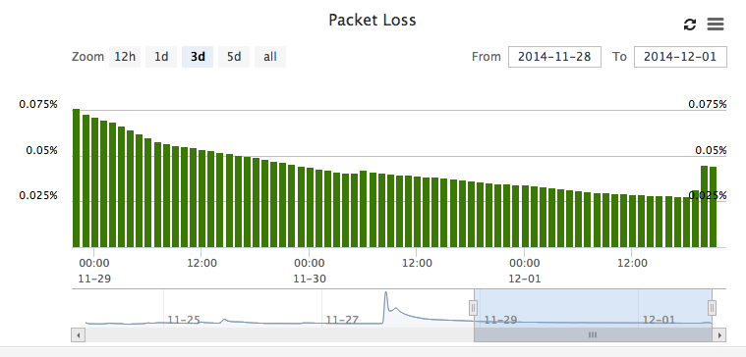

* + - * 1. *Camera LAN Bandwidth Usage (Camera BW):* Amount of bandwidth used for transmitting a camera’s video to its Bridge or Recorder, using a stacked bar chart with a dark blue segment indicating usage for Background plus On-Demand transmissions, and a light blue segment indicating usage for Real-Time transmission.See Figure 2 below.

*Figure 2. Metric - Camera BW*

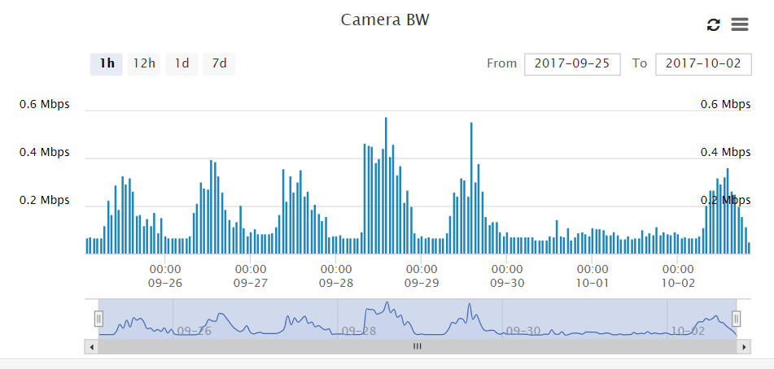

* + - * 1. *Camera Cloud Bandwidth Usage (Camera Cloud BW):* Amount of bandwidth used for transmitting a camera’s video to the Cloud VMS, measured in Megabits-per-second, using a stacked bar chart with a dark blue segment indicating usage for Background plus On-Demand transmissions, and a light blue segment indicating usage for Real-Time transmission. See Figure 3 below.

*Figure 3. Metric - Camera Cloud BW*

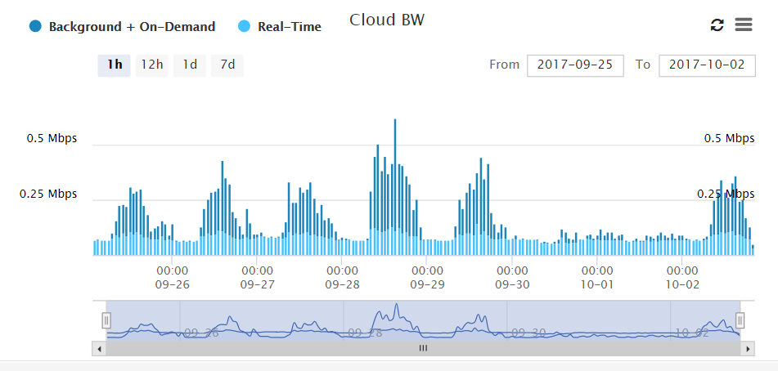

* + - * 1. *Camera Video Storage (Camera Storage):* Per-camera and total amount of camera video per Bridge or Recorder, written to Bridge buffers or Recorder Storage, measure in megabytes. See Figure 4 below.

*Figure 4. Metric - Camera Storage*

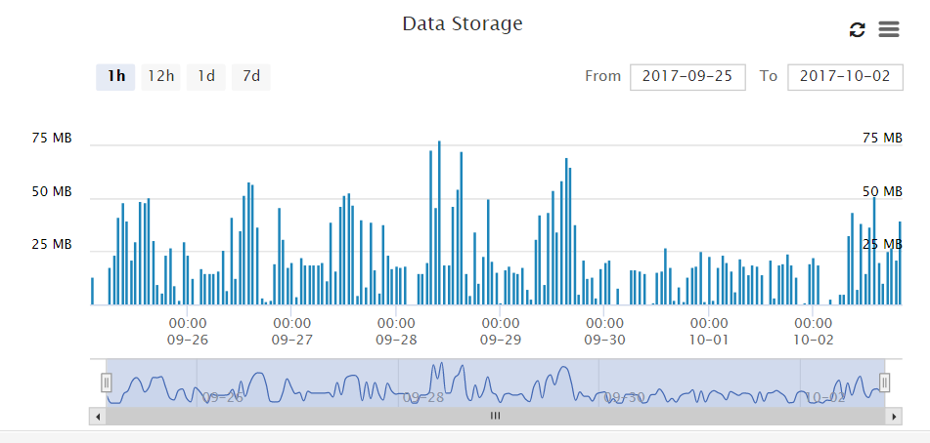

* + - * 1. *Camera Delta Video Storage (Camera Delta Storage):* Per-camera and total amount of disk data changed per Bridge or Recorder, written to and deleted from Bridge buffers or Recorder storage, measure in gigabytes, using both positive and negative values. Positive values indicate video being buffered or recorded (incoming video), and negative values indicate video being deleted for transmitted to the Cloud VMS (outgoing video). See Figure 5 below.

*Figure 5. Metric - Camera Delta Storage*

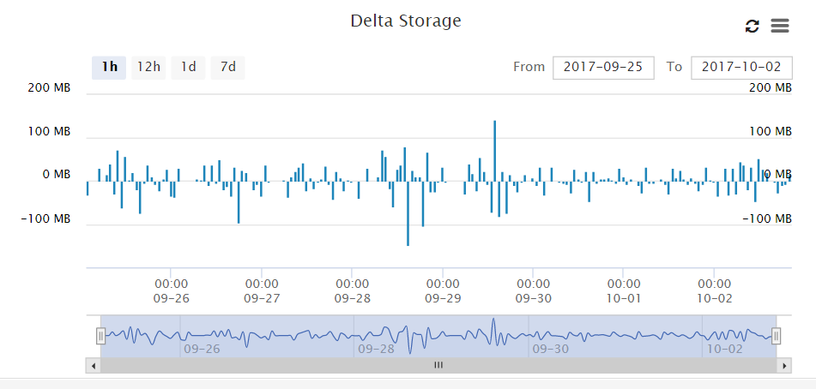

* + - * 1. *Cloud Bandwidth Usage (Cloud BW):* Total amount of bandwidth used for transmitting all video from a Bridge or Recorder to the Cloud VMS, measured in Megabits-per-second, using a stacked bar chart with a dark blue segment indicating usage for Background plus On-Demand transmissions, and a light blue segment indicating usage for Real-Time transmission. See Figure 6 below.

*Figure 6. Metric - Cloud BW*

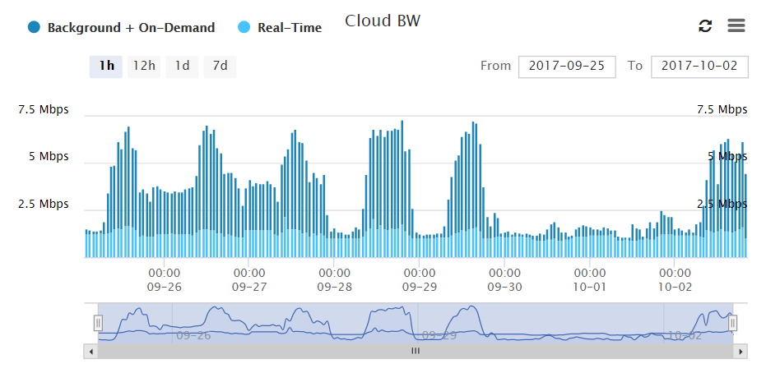

* + - * 1. *Cloud Bandwidth Speed Measured (Cloud BW Measured):* Average upload bandwidth speed between a Bridge and Recorder to the Cloud VMS, measured in Megabits-per-second. This measurement is utilized by each Bridge and Recorder when their Background Transmit setting is set to “Auto”. See Figure 7 below.

*Figure 7. Metric - Cloud BW Measured*

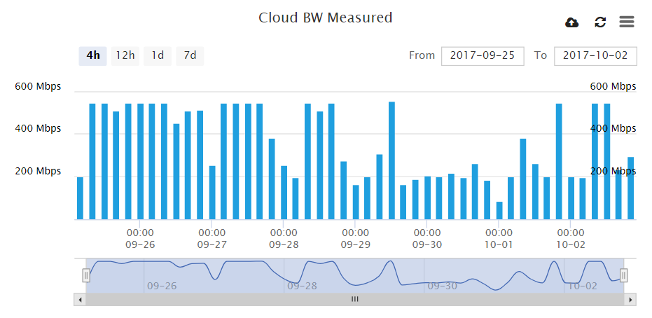

* + - * 1. *Bridge and Recorder Delta Storage (Delta Storage):* Total amount of disk data changed within a given hour, measured in megabytes, using both positive and negative values. See Figure 8 below.

*Positive values:* (dark blue bars reaching up) show video being written to buffers on a Bridge or storage on a Recorder.

*Negative values:* (light blue bars reaching down) indicate the deletion of video being transmitted to the Cloud VMS.

*Bridge Data Purge:* Negative values shown in purple indicate that video has been purged from the disk before transmission to the Cloud VMS.

*Recorder Data Purge:* Negative values shown in purple indicate video that has been purged from the disk before its retention period has been reached, to make room for arriving new video.

*Use of Purge Indicators:* When initially setting up the system or expanding it, Delta Storage metric whether the available cloud bandwidth and the video transmission settings are adequate to ensure no loss of video. Cameras whose data was purged are listed on the left-hand side of the Delta Storage window.

*Figure 8. Metric – Delta Storage*

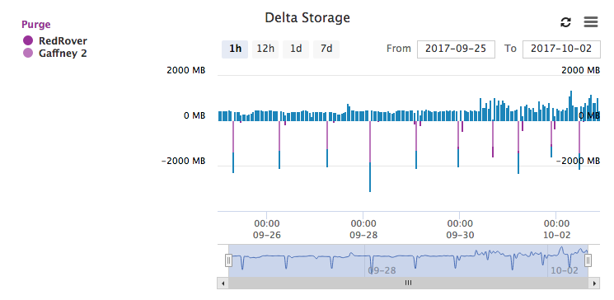

* + - * 1. *Bridge and Recorder Available Disk Space (Disk Space):* Totalavailable space on the buffer hard disk drive. See Figure 9 below.

*Figure 9. Metric – Disk Space*

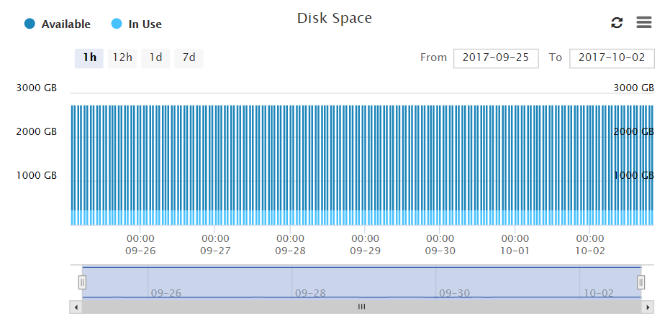

* + - * 1. *Bridge/Recorder Combined Camera LAN Bandwidth Usage (Camera BW):* Amount of bandwidth used for all of the cameras connected to a Bridge or Recorder, using a stacked area chart with each camera’s color identified in a legend at the left side of the chart. See Figure 10 below. Hovering the mouse pointer over the area chart pops up a detail window that shows the individual bandwidth amounts numbers for each camera (see Figure 11).

*Figure 10. Metric – Combined Camera LAN Bandwidth Usage with Area Chart*

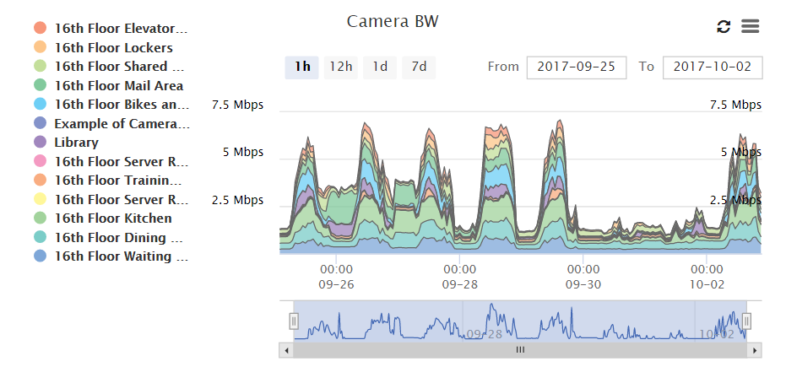

*Figure 11. Metric – Combined Camera LAN Bandwidth Usage with Area Chart Detail Window*

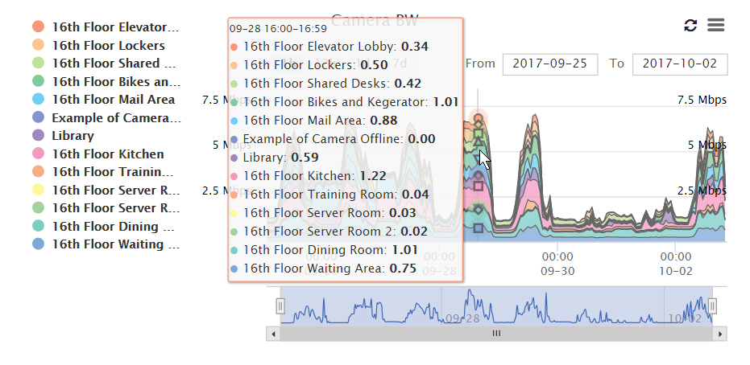

* + - * 1. *Bridge/Recorder Combined Camera Cloud Bandwidth Usage (Camera Cloud BW):* Per-camera amount of bandwidth used for transmitting each camera’s video to the cloud VMS, using a stacked area chart with each camera’s color identified in a legend at the left side of the chart, plus a line graph at the bottom of the chart. See Figure 12 below. Hovering the mouse pointer over the area chart pops up a detail window that shows the individual bandwidth amounts numbers for each camera, similar to what is show in Figure 11.

*Figure 12. Metric – Combined Camera LAN Bandwidth Usage with Area Chart Detail Window*

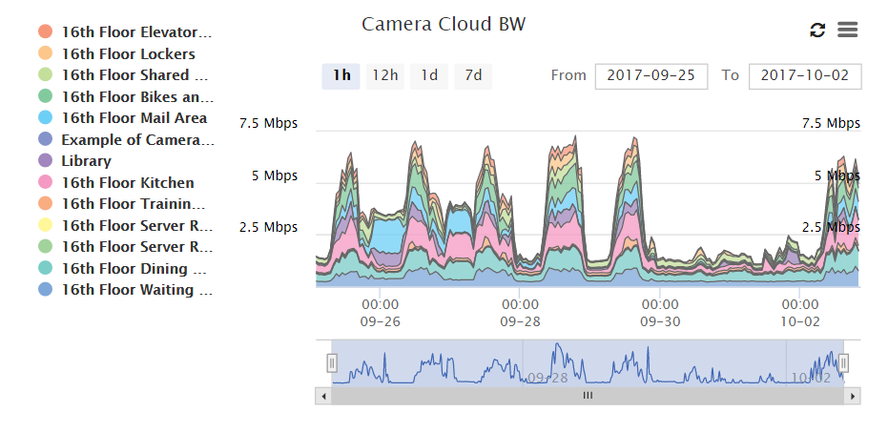

* + - * 1. *Bridge/Recorder Combined Camera Storage (Camera Storage):* Per-camera amount of camera video per Bridge or Recorder, written to Bridge buffers or Recorder Storage, measured in gigabytes, using a stacked area chart with a legend at the left side of the chart. See Figure 13 below. Hovering the mouse pointer over the area chart pops up a detail window similar to what is show in Figure 11.

*Figure 13. Metric – Combined Camera Storage*

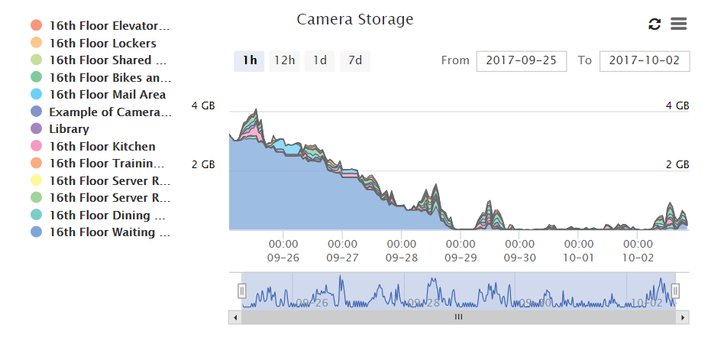

* + - * 1. *Bridge/Recorder Combined Camera Delta Storage (Camera Delta Storage):* Per-camera and total amount of disk data changed per Bridge or Recorder, written to and deleted from Bridge buffers or Recorder storage, measure in gigabytes, using both positive and negative values in a stacked area chart with a legend at the left side of the chart. Positive values indicate video being buffered or recorded (incoming video), and negative values indicate video being deleted for transmitted to the Cloud VMS (outgoing video). See Figure 14 below. Hovering the mouse pointer over the area chart pops up a detail window similar to what is show in Figure 11.

*Figure 14. Metric – Combined Camera Delta Storage*

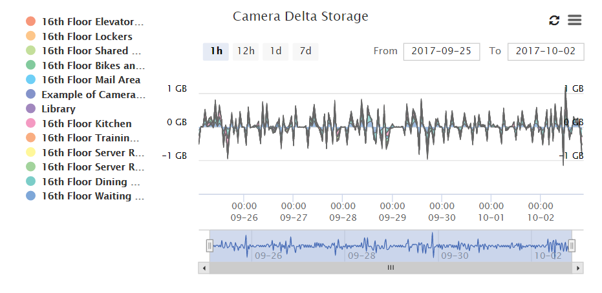

* + - * 1. *Metrics Chart Downloads:* Metrics graphs and charts shall be downloadable in the following file formats: PNG or JPEG image, SVG vector image or PDF document.
      1. *Dynamic Filtering:* Provide a way to dynamically filter the list of cameras displayed in any Layout view, that includes:
         1. *Filter Text Box:* A text entry box in which to type the filter criteria.
         2. *Filter Criteria:* Filter criteria include:

Assigned camera tags, such as “lobby”, “outdoor”, and “PTZ”

Camera location street address

Location, which may be street address, latitude/longitude, floor number

* + - * 1. *Filter Bookmarks:* Saved filters are called bookmarks. The filter bookmark list can be displayed for selection by clicking on the blue bookmark icon next to the Filter Text Box.
      1. *Alerts and Notifications:* Provide the following means of notifying users of camera detection events, alarms from cameras or other inputs, changes in system conditions, and system activity.
         1. *Alerts:* Optionally, as configured, record camera detection events such as motion detection, alarms from cameras or other inputs, changes in system conditions, and system activity as “alerts”.
         2. *Alert Display:* Provide on-screen notification of alerts via top-of-screen Alerts icon in web and mobile applications, with an accompanying display of the count of active alerts, and with selection of the icon or alerts count displaying a list of the active alerts.
         3. *Alert Configuration:* Provide the following alert configuration capabilities:

*Alert Active Time:* Configurable hours-of-day time period for each alert, when the Cloud VMS will generate that alert, otherwise no alert will be generated.

*Alert Who:* Selection of system users who should receive the alert.

*Alert Mode:* Provides user-defined custom control over when video motion alerts are created.

Alert Modes are user-defined descriptive names created to represent operational modes of the facility, such as “Normal Business”, “Special Event” and “Holiday Break”.

Administrator users select one Alert Mode to be the system’s active Alert Mode.

Alert configuration for each motion detection Region includes a checklist selection of one or more Alert Modes to be associated with the Region’s alert.

When video motion is detected, an alert is only created if the alert is associated with the active Alert Mode.

*Alert Level:* Two alert levels, High and Low. Users may specify that they receive only one level of alerts, or both.

*Alert Re-Arm:* To avoid excessive alert events, such as for motion alerts, provide a re-arm setting, configurable as follows:

*Immediate:* Alert re-arms immediately.

*After X Minutes:* Alert re-arms X minutes after the alert was last generated.

*After Quiet for X Minutes:* Alert re-arms X minutes after the alert-generating condition has ceased, for example, the cessation of motion after a period of motion that triggered a motion alert.

*Max Per Hour:* Limits the number of time a specific alert can be generated within a 60-minute period.

* + - * 1. *Alert Notifications:* Provide an option for users to be notified of alerts via email and mobile device push messages.
      1. *First Responder Camera Sharing:* Provide a means to share video with first responders through the following actions.
         1. *First Responder Camera Sharing Permission:* Administrator users assign users the system permission to perform first responder camera sharing actions.
         2. *Pre-Designation of Responders:* Authorized users enroll first responders by name, organization name, and email address.
         3. *Responder Camera Selection:* Authorized users select one or more cameras to be shared with first responders.
         4. *Authorization to Activate Emergency Video Feed:* At least one user must be given the system permission to activate the Emergency Video Feed, by selecting the Activate Responder Share main menu item.
         5. *Activation of Emergency Video Feed:* Upon activation, the “Activate Responder Share” menu item changes to “Deactivate Responder Share”, and enrolled first responders are sent an email messages informing them that the emergency video feed has been activated, and providing a link for them to access the shared video cameras.
         6. *Deactivation of Emergency Video Feed:* Authorized users deactivate the emergency video feed by selecting the ““Deactivate Responder Share” main menu item. Sharing of video ceases.
      2. *System Capacities:* Provide the following maximum capacities, constrained only by the physical performance capabilities of installed server hardware and network infrastructure:
         1. Unlimited cameras.
         2. Unlimited web app and mobile app software users.
         3. Unlimited user mobile devices.
         4. Unlimited user PCs or laptops.
         5. Unlimited video appliances.
         6. Unlimited sites.
         7. Unlimited cloud video storage capacity.
         8. Unlimited reseller accounts.
         9. Unlimited user accounts.
         10. On-premised video storage capacity determined by model and quantity of Cloud Managed Video Recorders installed.
         11. Recording rates of up to 30 frames per second per camera.
      3. *Data Security:* Provide the following data security capabilities:
         1. *No Inbound Connections:* Video appliances do not accept inbound internet connections:
         2. *Camera Isolation:* Cameras are isolated from the Internet.
         3. *No Open Ports:* Video appliances have no open network ports.
         4. *Camera Malware Protection:* Video appliances are protected against pre-installed camera malware by built-in appliance firewall.
         5. *Secure Data Connections:* Video appliances use encrypted TLS certificates for SHA 256 connections to Cloud Security Camera VMS.
         6. *Encrypted Video:* 256-bit AES encryption is applied to locally-buffered, locally-recorded and cloud-recorded video.
         7. *Appliance Authentication:* Appliance authentication via digital certificates.
         8. *System Hardening:* Provide system hardening guidance that describes data security, network security and physical security measures and best practices for securing the installed Cloud VMS against cyber attacks.
         9. *Triple Video Data Redundancy:* Provide triple redundant cloud data storage for video data, by maintaining three copies of video recordings and metadata saved on separate servers in the data center.
      4. *Secure Remote Access.* Provide three types of secure sign-in user access:
         1. *User Two-Factor Authentication:*

*Trusted Devices:* Establish trusted devices, which are mobile devices or browsers on specific computers that have previously registered using two-factor authentication It’s a device that is known to be associated with a specific user. Deny access for attempts to sign in using a non-trusted device.

*Security Codes:* Security code shall be a one-time-use code sent to a trusted device or phone number when the user logs in for the first time using a new device or browser.

* + - * 1. *Apple Touch ID Fingerprint Authentication:* Utilize iOS Keychain password storage and allow the user fingerprint to be used for login.
        2. *First Responder Real-Time Video Access:* Enable User-account administrators to set up first responder video access by:

Pre-designating first responders who are able receive immediate real-time security camera access during emergency situations, via the free Wisenet SKY Viewer mobile app or any major web browser.

Specifying which of their own personnel are authorized to activate emergency responder access when an incident is occurring.

* + - 1. *Automatic Offline Camera Recovery:* When a camera goes offline, the connected Bridge or Recorder shall execute the following offline camera recovery action sequence:
         1. *Connection Reset:* Reset the network connection to the camera.
         2. *Request Video Stream:* After connection reset, if the camera has not automatically initiated video stream transmission, request the video stream from the camera, re-authenticating if required.
         3. *ONVIF Reboot:* Issue the ONVIF reboot command to the camera.
         4. *Recommend Manual Power Cycle:* Issue an alert and conditionally send notification per notification configuration, to use the Camera Settings Maintenance Tab to cycle power to the camera.
      2. *Camera View for Off and Offline Cameras:* Provide useful information in the camera view for cameras that are off or offline, instead of displaying a blank camera view.
         1. Show the most recent good view image with a timestamp.
         2. Display “OFF” or “OFFLINE” in the center of the camera view.
         3. If Preview Video is not available, display “Preview Video is Temporarily Not Available” in the center of the camera view.
    1. *Cloud-Based Web Application:* The Cloud VMS shall be centrally managed via a cloud-based web application that includes the following functions and features:
       1. *Brower-Based Application:* Web application shall be 100% browser based and cross-browser compatible, and support most current browsers including Chrome, Edge, Firefox, Internet Explorer and Safari.
       2. *Reseller Dashboard:* Centralized monitoring and management of reseller accounts shall be provided via dashboard functionality.
       3. *User Dashboard:* Centralized monitoring and management of accounts and users shall be provided via dashboard functionality.
       4. *Automatic Application Updates:* Provide automatic web application software feature and security updates, with no action required on the part of the reseller or customer.
       5. *Help Display:* Provide context sensitive Help screens on each tab.
       6. *Default Settings Indication:* The system shall provide an indication if a setting is not the default or if the settings selected will not work.
       7. *Camera Driver Development:* If a driver is not currently available for a camera within the Cloud VMS application, the system shall provide an option for the installer to request support for the camera from the manufacturer by clicking on a button in the Available Camera screen. The manufacturer shall develop the driver and download it to the connected Bridge or Recorder to facilitate use of the camera on the system.
       8. *Functions and Features:* The web application shall include the following functions and features, described in detail in paragraph 2.2.H –Web Application Workspaces:
          1. View live or recorded video with optional audio.
          2. Search video based on timestamps and motion-based or alarm-based alerts.
          3. Manage account users.
          4. Manage camera settings.
          5. Enroll other users to share cameras with.
          6. Map and floor plan display for camera selection.
          7. Cloud VMS-based video analytics, including but not necessarily limited to:

Intrusion Detection

Line Crossing

Object Counting

Loitering

Camera Tampering

Thermal Camera Skin Temperature

* + 1. *Mobile Device Native Applications:* Provide native applications for Apple iOS and Google Android operating systems with the following features:
       1. View live and recorded video with optional audio, including PTZ control.
       2. Search video based on timestamps and motion-based or alarm-based alerts.
       3. Select cameras via map and/or floorplan display.
       4. Manage and configure cameras.
    2. *On-Premise Video Appliances:* Bridge and Recorder on-premise appliances shall be designed to work directly with the Cloud VMS software, shall be made by the Cloud VMS manufacturer and run software from the same manufacturer.
       1. *Cloud-Based Video Recording:* Bridges shall provide cloud-based video recording with local video buffering. Recorders shall support both local recording and cloud-based video recording.
       2. *Appliance Hard Drives:* Bridges and Recorders shall have internal hard drives.
          1. Bridge hard drives shall be configurable to provide 2 days of buffering for video data.
          2. Recorder hard drives shall provide video storage capacity as specified for each model of Recorder.
       3. *Appliance Networking Functionality:* Providetwo categories of network functionality for Bridges and Recorders, as designed for specific appliance models:
          1. *External Routers and Switches:* Some models of Bridges and Recorders shall be designed to utilize third-party routers for their connections to the Internet and to local Ethernet switches to connect to cameras.
          2. *Built-In Router Functionality.* Some models of Bridges and Recorders shall have built-in router and switch functionality, and shall have two network ports, one for Internet connection and one for Camera LAN connection.
          3. *Firewall Functionality:* All Bridges and Recorders shall contain firewall functionality to:

Block outgoing connection attempts from cameras, as a cyber security measure against cameras previously infected with malware.

Block inbound connection attempts from any source as a cyber security measure against external network-based threats.

* + - 1. *Camera Support:* Bridges and Recorders shall support IP cameras; selected models of Bridges and Recorders shall support analog cameras.
      2. *Network Separation:* Bridges and Recorders shall have separate network ports for the inbound camera traffic (CamLAN) and the outbound upload traffic (WAN) connected to the Internet.
         1. CamLAN shall be a gateway only network with no route outbound.
         2. CamLAN functionality shall by default provide DHCP in the address range of 10.143.0.100 - 10.143.255.254.
      3. *Video Analytics Processing:* Bridges and Recorders shall perform video analytics metadata extraction and send metadata to the Cloud VMS in real time.
      4. *Local Display:* Provide local video display monitor capability to be used for public view of cameras and Bridge/Recorder maintenance. including the following functionality:
         1. *Local Display via Monitor:* Provide local display capability via USB keyboard connection and one of the following display monitor connections: HDMI, VGA, DVI, or DisplayPort.
         2. *Local Display via Browser:* Provide direct login to Bridge and Recorder via web browser on a LAN, requiring username and password login credentials.
         3. *Layouts Available:* Provide a means to select layouts for local display that contain cameras attached to the Bridge or Recorder.
         4. *Keyboard Shortcuts:* Support Cloud VMS keyboard shortcuts in the local display function, including access to local display help by pressing “h”.
         5. *Video Appliance Maintenance Support:* The Local Display shall offer the following menu for maintenance functions:

System Info

Network Interface Info

Network Diagnostic Info

View DHCP leases

Monitor bandwidth

Seen cameras (discovered on network but not enrolled in VMS)

Configure network

Camera LAN

WAN

Erase & Reset

Change password

Support tunnel

* + 1. *Cloud VMS API:* Provide a full public API for application development and systems integration.
       1. *API Key:* Provide an API Key mechanism to identify registered developers and their applications.
       2. *Developer Account.* Provide development accounts for application and integration development and testing.
       3. *API Key Generation:* Provide an Account Settings function to automatically generate an API key for the account holder’s use.
       4. *API Documentation:* Openly publish the full API documentation online.
    2. *Web Application Key Workspaces:*
       1. *User Interface:* Provide a menu-driven user interface that displays content based upon the individual user type and the logged-in user’s privileges. Application shall support three Dashboards: Reseller Dashboard (for a reseller Master Account), and User Dashboard (simply labelled “Dashboard”).
       2. *Reseller Dashboard:* Provide the following:
          1. *Equipment Online Status.* Color-coded pie charts displaying online/offline status of Bridges, Recorders and Cameras.
          2. *Reseller Account Summary.* A summary page displaying the number of:

Active Sub Accounts (customer accounts)

Active Bridges/Recorders.

Inactive Bridges/Recorders.

Active Cameras.

Available Cameras.

* + - * 1. *Notifications.* System level and camera notifications for the last 24 hours.
        2. *Accounts.* Summary list of all reseller customer sub-accounts displaying:

Account Status

Account Name

Bridge/Recorder Status (online/offline/off)

Camera Status (online/offline/off)

Average Retention (days of video storage)

Number of Users

Last Login Date

* + - * 1. *Sub-Account Action buttons.* For each sub account, provide the following action buttons:

*Cameras:* Access to camera views and camera settings.

*Settings:* Reseller account control settings.

*Status:* Active, Login Disabled, Account Disabled

*Admin:* Disable All Admin Access

* + - * 1. *Master Account Settings:* Settings for re-branding the Cloud VMS with the resellers business name and logo:

Branding Enabled option.

Company Name.

Sub domain on eagleeyenetworks.com.

Small logo upload.

Large logo upload.

* + - * 1. *Installer Tools:* The Installer Diagnostic Tool page shall provide access to the following camera information:

*Camera Status:* On, Off, Deleted.

*Name:* Camera name.

*IP Address:* IP Address assigned to the camera.

*Duty Cycle:* Amount of time full video was recorded on local drive during the last 24-hour period. Duty cycle is represented as 0-100%.

*Preview/Live Video size:* Indicates Horizontal / Vertical size and quality.

*Cloud Retention:* Days of video stored in Cloud

*Settings:* shortcut to camera settings

* + - 1. *User Dashboard:* Provide the following functionality:
         1. *Cameras:* Management and use of all Bridges, Recorders and connected cameras the logged-on user has access to, based upon the user’s assigned permissions,
         2. *Cameras Shared With Me:* Listing of all cameras other users have shared with the logged-on user.
         3. *Available Cameras:* Listing of cameras that are visible on the Bridge network but have not been connected to the Bridge.
         4. *Managed Switches:* Listing of the Managed Switches the user can access, enabling the user to cycle power on individual ports and all ports, and to reboot the switch.
         5. *Layouts:* Management of nameable views containing multiple cameras providing access to live or recorded video.
         6. *Tags:* Selection list of tags for use in filtering the set of displayed cameras.
         7. *Users:* List of Users identifying Administrators, with Email Addresses, User Status and Last Login (date/time). Provide action buttons for access to Settings, Password, Email and User Deletion.
         8. *Map:* Map screen for one or more Google maps or floorplan graphics, on which:

Clickable camera icons can be placed, with optional camera fields of view areas.

Outlines can be drawn to further define building features and camera locations.

Clicking on camera icon shall call up live Preview Video.

From Preview Video view action buttons provide access to recorded video, Full Video and Camera Settings.

* + - * 1. *Notifications:* A log of system notifications with time, notification and action.
      1. *Notifications:* Provides a log of system notifications with time, notification and actions available, such as requesting a video download again, or copying an original video clip’s MD5 checksum to verify that the downloaded video has not been tampered with.
      2. *Cameras:* From the Dashboard, the Cameras window will display the following:
         1. *Status:* Icons indicating the online, offline, or other status of cameras, Bridges, Recorders, and Managed Switches, including:

*Off:* Camera is “off”, meaning that it is not transmitting video, and not recording, per schedule or manual setting.

*Offline:* Cannot communicate with the device

*Internet Offline:* Bridge or Recorder cannot communicate with the Cloud VMS.

*Verified:* Online and in good operational status.

*No Access:* User name and password mismatch.

* + - * 1. *Name:* Device Name
        2. *Tags:* Displaysdata according to type of device listed:

*For Cameras:* Tags assigned to the camera.

*For Bridges:* Bridge or Recorder serial number.

*For Cameras Shared With Me:* no data displayed.

* + - * 1. *Owner:* Applies only to Cameras Shared With Me, name of camera owner is displayed
        2. *Bridge:* Applies only to Available Cameras and Managed Switches, bridge the device is connected to.
        3. *Actions:* Actions available based upon device type:

*For Cameras:*

View camera history.

Change camera settings.

Open VPN to camera.

Open analytics graphs.

Remove camera from account.

*For Bridges:*

Change bridge settings.

Remove bridge from account.

*For Cameras Shared With Me:*

View camera history.

Change camera settings.

Remove camera from account.

*For Available Cameras:*

Add Camera to Account.

Open VPN to Camera.

Replace Camera.

*For Managed Switches:*

Change Switch Settings (limited to power cycling ports and rebooting switch).

* + - 1. *History Browser:* Provide playing of Preview Video and Full Video segments, by displaying full-width a single camera’s video at top of screen, and providing draggable graphical Timeline controls at bottom of screen that include the following functionality, illustrated in Figure 10 below.

*Figure 10. History Browser Timeline Controls*

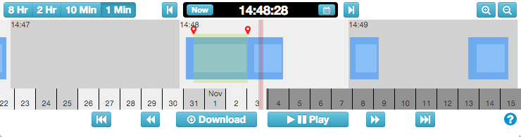

* + - * 1. *Time and Date Control.*

*Video Display Timeline:* Below the video display, provide visual Timeline graphical control with the following functionality.

*Timeline Zoom:* At the top left side of the Timeline, provide set of buttons to zoom time span of Timeline to: 8 or 2 hours, 10 minutes or 1 minute (labeled 8 Hr, 2 Hr, 10 Min and 1 Min).

*Video Clock Time Control.* In the center of the Timeline, provide a time and date control time bar at top center of Timeline, having elements as follows:

*Time Display:* Six-digit time display (formatted hh:mm:ss, such as 01:23:45) at top center of Timeline, which when clicked on pops up a Time-of-Day Selector.

*Now Button:* Button labeled “Now” on left-hand side of Time Display to set video clock to current time and display live video.

*Calendar Button:* Calendar icon button on right-hand side of Time Display to pop up a calendar for selecting new timeline date.

*Next/Previous Frame:* At left-hand sides of Time Display provide button with Previous Frame icon, at right-hand side provide button with Next Frame icon, for frame by frame video control.

*Camera View Zoom.* At the top right side of the Timeline, provide two magnifying glass controls, labeled “+” and “-”, for zooming in and out of the camera view.

* + - * 1. *Video Segment Bar:* Provide a wide strip across the middle of the Timeline for graphically indicating when video recordings start and stop, and providing additional video timeline information described below. Dragging the Video Segment Bar left or right moves the Timeline backward or forward.

*Motion Activity:* Use a light blue color to indicate motion in the video.

*Full Video:* Use a darker blue color to indicate Full Video.

*Current Video Frame:* Use a stationary red centerline cursor to mark the location of the currently displayed video frame.

*Timeline Zoom:* Visually represent the timeline zoom by alternately coloring white and light gray each zoom segment, which will be 8-hour, 2-hour, 10-Minute or 1-Minute time periods. Include a four-digit 24-hour time display (formatted hh:mm, such as 14:56) at the start of each zoom segment.

*Video Selection:* Provide video selection using Shift + click to set the beginning the selection and Shift + click to set the end of the selection, marking the selected segment in yellow, and placing red location icons just above the beginning and ending points of the selection.

* + - * 1. *Sliding Date Bar:* Provide a draggable sliding date control showing the days of the month, with weekends colored in medium gray, and weekdays in light gray. Dark gray is used to indicate future days when the Timeline display is set to Now. Dragging the Date Bar left or right moves the Timeline backward or forward.
        2. *Play and Download Controls:* Provide controls for playing and downloading video in the bottom controls row of the Timeline.

*Play/Pause:* Button to alternately play and pause Full Video or a selected segment of video.

*Previous/Next Key Image:* Buttons with double-chevron icons (<< and >>) to move backwards and forwards to the next available Key Image.

*Previous/Next Key Video Segment:* Buttons with double-chevron plus bar icons (|<< and >>|) to move backwards and forwards to the next available recorded video segment.

*Download Button.* Initiates downloading of a selected video segment as an MP4 file, by displaying a Download Video setup window containing the following data fields and controls.

Start Date/Time.

Stop Date/Time.

Type (Video, Bundle, Preview Time Lapse).

Description (for typing a description).

Time Stamp: (for setting the Time Stamp on or off).

Notes: (for entering notes).

Cancel and Download buttons.

*Download Notification:* If it will take more than 15 seconds to retrieve the video for download, a Start Video Download dialog window will be displayed, prompting for a description of the video, and providing options to cancel the download or continue. If notifications are enabled, a notification will be issued when the video is ready for download, and the on-screen notification indicator will appear.

* + - * 1. *Gallery View:* Provide a multi-image multi-frame view for reviewing and examining recorded video, with Timeline controls below it, and the following functionality:

*Initiating Gallery View:* Utilize Timeline’s Zoom Out button to initiate History Browser’s Gallery View, presenting an array of time-stamped incremental still images for efficient video review, starting with a nine-image array,

*Increasing/Decreasing Image Count:* Utilize Zoom Out and Zoom In buttons to increase and decrease image array size through three configurations:

*9 Images:* 3 x 3 array.

*16 Images:* 4 x 4 array.

*25 Images:* 5 x 5 array.

* + - * 1. *Additional Timeline Colors:* Provide expanded color coding for the Browser History Timeline when System Notifications are enabled, representing the following conditions:

*Offline:* Red.

*Off:* Orange.

*Video:* Darker Blue.

*Motion:* Lighter Blue.

*Internet Offline:* Yellow.

* + - * 1. *Gallery View Image Selection Modes:* Provide a pop-up selection list for three modes of Gallery View image selection, with the first selection list item based upon the Timeline Zoom setting.

*Time-Based Mode:* Images selected based on intervals Timeline Zoom level, so that the first selection item is 4 Hours, 1 Hour, 5 Minutes or 30 Seconds.

8-hour zoom shows 1 frame every 4 hours.

2-hour zoom shows 1 frame every hour.

10-minute zoom shows 1 frame every 5 minutes.

1-minute zoom shows 1 frame every 30 seconds.

*Key-Image Mode:* Key Images selected going backwards and forwards from the Timeline Cursor value, with Next Key Image and Previous Key Image buttons controlling the forward and backward advancement of image selection.

*Video Mode:* The first Key Image is selected from recorded video segments. Clicking on an image in the array centers it in the array, and refreshed the images around it. Scrolling the Timeline refreshes the images. Double-clicking on an image brings it full screen and moves the History Browser cursor to that point in time.

* + 1. *Web Application Camera setup:*
       1. *Camera Tab:* Camera setup shall be managed from the Camera Settings selection available when viewing the camera video from within the Dashboard Layout or Camera views. The Camera Set-up selection will open a window with Tabs for each of the following configuration settings.
       2. *Camera Tab Settings and Action Buttons:*
          1. On/Off checkbox.
          2. Schedule dropdown with options:

24 hours.

Work hours (Mon-Sun, 8:00 AM – 5:30 PM).

Non-work hours.

Custom hours.

* + - * 1. Name (of camera).
        2. Login and Password (of camera).
        3. Time Zone: only one time zone can be selected for a Bridge or Recorder installation.
        4. Tags: assigned to a camera will allow groupings of cameras to be selected for viewing or management.
        5. Notes: user created notes.
        6. Information (as provided by camera through ONVIF integration).
        7. Get RTSP Info.
        8. Delete Camera button.
      1. *Retention Tab Settings:*
         1. Cloud Retention: video retention in days; applies to a Bridge or Recorder
         2. Local Retention: video retention in days; applies only to a Recorder
      2. *Resolution Tab Settings:*
         1. *Preview Video setting options:*

*Resolution:* resolution selections are

CIF (320 x 180)

Standard (640x360)

High (1280x720)

*Transmit Mode:* Always, On Demand

*Quality:* Low, Medium, High

*Update Rate:* 0.25, 0.5, 1 – 16 seconds

*Max Bandwidth:* 50 selections from 8 kb to 27 mb

* + - * 1. *Full Video Recording setting options:*

*Resolution:* resolution selections are

CIF (320 x 180)

Standard (SD1 - 640x360)

High 1MP (HD1 - 1280x720)

1080P 2MP (HD2 - 1920x1080)

3MP (HD3 – 2048x1536)

4MP (HD4 – 2240x1680)

5MP (HD5 – 2560x1920)

10MP or higher (HD10 - 3872 x 2592)

*Transmit Mode:* Background, On Demand

*Quality:* Low, Medium, High, Max-fps

*Bit Rate:* selection from:

Variable

1000 kb

2000 kb

4000 kb

8000 kb

16000 kb

32000 kb

64000 kb

* + - 1. *Dewarping Tab Settings:* Set up multiple viewports for 360⁰ fisheye cameras.
         1. *Viewport Type:* Single, Double Panorama, and Quad.
         2. *Orientation*: Wall, Ceiling, and Floor.
         3. *Virtual PTZ*: Available within the preview image.
      2. *Motion Setup Tab:*
         1. *Master Motion Sensitivity:* slider values from 0 to 100.
         2. *Master Motion Object Size:* Small, Medium, Large.
         3. *Preview Video Window: Camera’s* Preview Video showing defined motion regions.
         4. *Region/Alerts – Region Settings:*

*Order:* Order in which Regions are processed.

*Name:* Name of Region

*Sensitivity:* slider values from 0 to 100.

*Object Size:* Small, Medium, Large

*Actions Buttons:*

Edit Alerts

Remove Motion Zone

Undo Motion Changes

* + - * 1. *Region/Alerts – Alert Settings:*
        2. *Alert Enable:* On/Off.
        3. *Alert When:* Selection of schedule options:

24 hours.

Work hours (Mon-Sun, 8:00 AM – 5:30 PM).

Non-work hours.

Custom hours.

* + - * 1. *Re-arm:*

Immediate.

After: # minutes.

After: quiet # minutes.

* + - * 1. *Max Per Hour:* # of alerts.
        2. *Alert Who:* All, checkbox list selection of users.
        3. *Alert Level:* High, Low.
      1. *Analytics Tab Settings:*
         1. Enable Analytics: Checkboxes to enable Counting, Line Crossing, Intrusion Detection, Loitering, Camera Tampering and Thermal Skin Temperature.
      2. *Thermal Tab Settings:*
         1. *Thermal Temperature Detection*

Enabled: Checkbox On/Off

Video: Checkbox On/Off

Units: Checkbox Celsius or Fahrenheit

* + - * 1. Alert Configuration

*Minimum Temperature:* # in degrees which will trigger an alarm if above set number.

*Alert When*: Selection of schedule options:

24 hours.

Work hours (Mon-Sun, 8:00 AM – 5:30 PM).

Non-work hours.

Custom hours.

*Re-arm:*

Immediate.

After: # minutes.

After: quiet # minutes.

*Max Per Hour:* # of alerts.

*Alert Who:* All, checkbox list selection of users.

*Alert Level:* High, Low.

* + - 1. *Audio Tab Settings:*
         1. Audio enabled: Checkbox On/Off
         2. Copy Audio To: List of connected cameras
      2. *Location Tab Settings:*
         1. Location Name.
         2. Street Address (street, city, state, zip).
         3. Latitude.
         4. Longitude.
         5. Azimuth.
         6. Range (in feet).
         7. Floor.
      3. *Metrics Tab:* See the five camera metrics defined in paragraphs 2.2.C.9.a, b, c, d and e:
         1. Packet Loss.
         2. Cloud Bandwidth.
         3. Camera Bandwidth.
         4. Storage.
         5. Delta Storage.
      4. *Maintenance Tab:* If connected to manufacturer’s Managed Switch, provides the option to Power Cycle the Camera.
    1. *Web Application User Management:* 
       1. *User List:* Users option in the Dashboard shall allow for an Administrator to manage all users associated with the system. The Administrator shall be provided display of a downloadable list of all current users associated with the account.
       2. *User ID:* User email addresses serve as the system’s unique identifier for users.
       3. *User List Information:* The list shall provide the following information:
          1. Name.
          2. E-mail Address.
          3. Administrator (checkmark indication).
          4. Status (Active, Pending Validation or Deleted).
          5. Last Login (date/time).
          6. Settings Actions buttons for each user, available per Status of user:

Change user settings.

Resent confirmation email.

Remove user from account.

Send password reset email.

* + - 1. *User Settings Window:*
         1. *Access Tab:*

*Disable User:* Checkbox.

*Access Period:* Selection list options:

24 hours.

Work hours (i.e. Mon-Sun, 8:00 AM – 5:30 PM).

Non-work hours.

Custom – selection displays Add Period option.

*Permissions:* Options dropdown:

Edit Account Settings.

Edit Layouts.

Edit Cameras No Billing.

Turn Cameras On And Off.

Edit Motion Areas.

Change Cameras.

Edit Users.

Edit All And Add.

Edit Sharing.

PTZ Live.

Edit PTZ Stations.

View Live Video.

View Recorded Video.

Download Video.

View Previews.

*Employee ID:* Text entry.

* + - 1. *Cameras Tab:* Allows individual cameras to be assigned to user
      2. *Layouts Tab:* Controls the user’s access to layouts. Access to a layout automatically gives access to all cameras in the layout.
      3. *Administrator User:* Upon log-in, if the User is an Administrator they will have the following options under the Account Settings selection:
         1. *Control Tab:*

Turn off all cameras

Turn on all cameras

Create API key

* + - * 1. *Days Tab:*

Time Zone: (selection drop-down)

Work days: (selection drop-down)

Work hours: (from / to setting)

* + 1. *Web Application Archive Management:* 
       1. *Archiving:* feature which allows the saving of video clips outside of retention while utilizing the Wisenet SKY Cloud VMS robust and redundant cloud storage.
       2. *Actions:* once one or more files or folders are selected it is possible to share, move the selection to another location in the Archive, copy the selection, delete or download the selection.
       3. *New folder:* click on the icon in order to create a new folder in the Archive and give it a name.
       4. *Name:* name of the folder or the file in the Archive.
       5. *Created:* timestamp of when the folder or the file was created.
       6. *Size:* the size of the folder or the file in the Archive.
       7. *Shared:* an icon with people indicates that the file or the folder is shared. If the folder or the file does not have an icon in this column, it means this item is not shared.
       8. *View:* shows the preview of the selected file with playback of video.
       9. *Info:* shows the additional information about the file: date and time of creation, who and when created, date shared, the link if the file or the folder was shared, description, and list of tags.
    2. *Web Application Account Settings:* Provide the following account settings:
       1. *Control Tab: Provides three control buttons:*
          1. *Turn off all Cameras:* Press this to turn off all cameras
          2. *Turn on all Cameras:* Press this to turn on all cameras that are off.
          3. *Create API Key:* Generate a Wisenet SKY API Key for this account, for use in systems integration and software development.
       2. *Days Settings Tab:*
          1. *Time Zone:* Selection drop-down list of time zones.
          2. *Work days*: Selection drop-down list:

Monday – Friday.

Monday – Saturday.

7 Days a Week.

* + - * 1. *Work hours:* From/To time settings.
      1. *Security Settings Tab:*
         1. *Web Timeout:* Users will automatically be logged out after the selected time period:

15 Minutes

1 Hour

4 Hours

8 Hours

12 Hours

24 Hours

1 Week

* + - * 1. *Inactive Session Timeout:* Users will be automatically logged out after the selected amount of inactivity. At a minimum, a mouse click or keypress is considered to be activity.

None.

5 Minutes

15 Minutes

1 Hour

4 Hours

8 Hours

12 Hours

24 Hours

* + - * 1. *Max Login Attempts:* Maximum number of consecutive failed login attempts allowed within a 24-hour period, before a user will be forced to do a password reset.
        2. *Include Picture in System Notifications:* Checkbox to specify whether images will be displayed in system notification emails.
        3. *Two-Factor Authentication:* Checkbox to enable two-factor authentication.
      1. *Security Settings Tab:*
         1. *Enable RTSP cameras:* Checkbox to enable cameras that do not support the ONVIF protocol to appear on the Dashboard.
         2. *Standard Camera Logins:* Provides a Password Locker for usernames and passwords allows a standard username and password to be automatically applied to all cameras.
      2. *Alerts Settings Tab:* Provides a means to create and delete Alert Modes, for selection as the system Active Alert Mode. See paragraph 2.2.C.11.c.3 – Alert Mode.
      3. *Notifications Setting Tab:* Checkbox to disable system notifications.
      4. *Privacy Settings Tab:* Checkbox to enable privacy on cameras so that reseller is unable to view any video.
      5. *Sharing Settings Tab.* Provides a list of available cameras to select for sharing with new users, enrolling them in the account using their email addresses.
         1. *Permissions:* Limited permissions may be assigned in addition to camera viewing:

Edit Motion Areas.

PTZ Live.

Edit PTZ Stations.

* + - 1. *Responders Settings Tab:* Provides the means to set up first responder video sharing, as described in paragraph 2.2.C.12 – First Responder Camera Sharing.
      2. *Responders Settings Tab:* Provides a selection list to specify the default retention period for video stored in the Cloud VMS:
         1. None.
         2. 2 Days.
         3. 3 Days.
         4. 7 Days.
         5. 14 Days.
         6. 30 Days.
         7. 60 Days.
         8. 90 Days.
         9. 180 Days.
         10. 1 Years.
         11. 2 Years.
         12. 3 Years.
         13. 5 Years.
      3. *Local Display Settings Tab:* Provides settings for the Local Display function described in paragraph 2.2.F – Local Display.
         1. *Local Display via Browser:* Checkbox to enable.
         2. *Local Display via Monitor:* Checkbox to enable.
         3. *Layouts Available:* Layouts containing cameras connected to the Bridge or Recorder, for selection to make available through Local Display.
         4. *Layouts on Display:* List of layouts available for viewing via Local Display.
    1. *Web Application Bridge setup:*
       1. *Bridge setup tab*: shall be managed from the Bridge Settings selection available when viewing the bridge from within the Dashboard Layout. The Bridge Set-up selection will open a window with Tabs for each of the following configuration settings.
       2. *Bridge Tab Settings and Action Buttons:*
          1. *Bridge Name:* Name for the bridge that is displayed in the dashboard.
          2. *Time Zone:* Selection drop-down list of time zones
          3. *Default Transmit Bandwidth:* Select % of available, fixed, minimum bw mode and maximum bw mode.
          4. *Schedule Transmit Bandwidth:* Select None, Work Hours, Non-work hours, and Custom.
          5. *Media Shortcut Enabled:* This enables you to view both previews and live video directly from the Bridge/CMVR to your computer if you are on the same local network. This results in both previews and live video loading faster (as long as the video is on the Bridge, and not in the cloud). Previews are shown at up to 8 frames per second, giving a better user experience.

Metadata must still come from the cloud; this includes any analytics and history browser timeline information (notification indicators, motion regions). Prior to media shortcut, all video had to be sent to the cloud first, then to the browser.

* + - * 1. *Media Shortcut Override:* This section is used for networks that are more advanced or testing purposes. This will take 3 different inputs: "CamLAN" (which is the CamLAN IP), "WAN" (which is the WAN IP), or any other IP (example: 192.168.2.4). Media Shortcut will automatically fill in "Override" with the "WAN" IP address by default.
        2. *Bridge Information:* Displays the SSN, IP address, ESN, GUID, and other information about the bridge.
        3. *Delete Bridge:* press this to delete a bridge. You may delete a bridge only when no cameras are connected to it
        4. *Turn off Cameras:* press this to turn off all cameras connected to the bridge. This does not turn off power, but turns off recording. No video is recorded when cameras are turned off.
        5. *Turn on Cameras:* press this to turn on all cameras that are off. This is not power. Cameras that are off do not record. This will turn cameras on and record video based on each camera’s settings.
      1. *Location:* 
         1. *Location Name:* common name of bridge location.
         2. *Street Address:* address where the bridge is located.
         3. *Location Type:* drop down selection that best describes the bridge location type.
         4. *Latitude/Longitude:* the location of the bridge.
         5. *Floor:* if in a building the bridge is located on.
      2. *Metrics:*
         1. *Cloud BW:* the bandwidth used during live viewing and synchronization to the Wisenet SKY Cloud.
         2. *Background+ On-Demand:* the synchronization of video to the cloud as well as the viewing of video that is not yet in the cloud. Real-Time is the preview video that is being transmitted directly to the cloud. Either can be viewed one at a time by clicking directly on the name.
         3. *Cloud BW Measured:* the bandwidth as measured while sending data to the Wisenet SKY Cloud.
         4. *Storage:* the space Available and In Use, which is video temporarily buffered prior to synchronizing with the Wisenet SKY Cloud. If video does not get transmitted to the cloud before the Available space is filled, then the oldest day's video will be purged to make room for current video
         5. *Delta Storage:* the difference between the video buffered locally and the space freed by synchronizing to the Wisenet SKY Cloud or by purging.
         6. *Cam Cloud BW:* the amount of bandwidth used to live view and synchronize video from the bridge to the Wisenet SKY Cloud per camera, displayed as separate colors.
         7. *Cam Storage:* the amount of video stored per camera locally displayed as separate colors.
         8. *Delta Cam Storage:* the amount of video stored locally and the space freed by synchronizing to the Wisenet SKY Cloud.
      3. *Local Display:*
         1. *Local Display via Browser:* check this box to enable direct login to Bridge via web browser on LAN (Local Area Network).
         2. *Local Display via Monitor:* check this box to enable video output on the Bridge's external video connector which depends on the Bridge model.
         3. *Layouts Available:* Only layouts that contain cameras attached to this bridge can be used for local display. Select one or more layouts by clicking, then drag and drop to the right.
         4. *Add All:* adds all available layouts to Local Display.
         5. *Remove All:* removes all layouts from Local Display
         6. *Cancel:* Cancels and closes Bridge Settings.
         7. *Save Changes:* saves any changes and closes Bridge Settings.
    1. *IP and Analog Camera Compatibility:* 
       1. *IP Cameras.*
          1. *ONVIF Support:* Bridge and Recorder video appliances shall support ONVIF Device Profile S.
          2. *IP Camera Compatibility.*

*Testing:* Manufacturer shall maintain a list of compatible IP camera and analog video encoder models, tested and verified to support the 3500+ IP camera models located at

https://www.hanwhasecurity.com/wisenet-sky-camera-compatibility-list.

*Published Test Results:* Manufacturer shall publish test results documenting support for each camera’s audio capabilities, special features, video resolutions, and any camera control or operability issues identified in testing. Published results must include firmware versions tested.

*Requests for Testing:* Manufacturer shall provide a means for resellers and customers to request that specific makes and models of cameras be tested for compatibility.

* + - 1. *Analog Cameras:*
         1. *Analog Camera Support:* Analog cameras shall be supported by connecting them to compatible Encoders.

1. Execution
   1. INSTALLATION
      1. The contractor shall install all proposed systems components in accordance with manufacturers' instructions, and as shown on project Drawings.
   2. EQUIPMENT
      1. All switches, Bridges/Recorders and Routers shall be installed in an environmentally suitable location approved by the Owner.
   3. POWER
      1. The contractor shall verify the locations of available 120 VAC power for equipment and notify Owner if sufficient power is not available.
   4. TRAINING
      1. All user training shall be performed by Cloud VMS manufacturer factory-certified employee of the contractor or an employee of the Cloud VMS manufacturer.
      2. Factory certification training shall prepare intended users to perform all system administrative functions and to perform the day-to-day tasks that would be required of an operator using the system.
   5. PROJECT CLOSE-OUT
      1. Contractor shall test and verify that all systems are operating according to contract documents and specifications.
   6. Commissioning
      1. Commissioning Procedure.
         1. Owner's representative shall witness Commissioning procedure.
         2. Contractor shall conduct the Commissioning procedure.
         3. Commissioning procedure consist of detailed inspections of each equipment item, and demonstration of full system functionality as Owner intends to use it.
   7. System Acceptance
      1. System shall be ready for acceptance one (1) week prior to the system "on-line" date established by the Owner. Contractor shall coordinate and obtain the date from the Owner's representative.
      2. Prior to scheduling Commissioning, Contractor shall submit Commissioning procedure to Owner for approval.
      3. As a requirement of Owner acceptance, Commissioning procedure shall be completed and documented.
      4. Warranty coverage shall not begin until Commissioning documentation has been accepted by Owner.

End of Section

Section 28 23 11.16

Video ApplianCES

PART 2 General

* 1. Video ApplianceS
     1. Manufacturer:
        + 1. Wisenet SKY, Hanwha Techwin America, 500 Frank W. Burr Blvd., Suite 43, Teaneck, NJ 07666
          2. Telephone: (877) 213-1222
          3. Website: [www.HanwhaSecurity.com,](http://www.HanwhaSecurity.com,) www.WisenetSKY.com
        1. Substitution Limitations: No Substitutions.
        2. Product Options:
           1. *Bridges:* Receive and analyze camera video streams, provide on-premise buffering for bandwidth management, detect camera issues, and forward video and system status information to the Wisenet SKY Cloud Data Center.
           2. *Cloud Managed Video Recorders (CMVRs):* Provide all the functionality of Bridges, plus on-premise video recording.
     2. Appliance Performance / Design Criteria:
        1. See Section 23 28 00 2.2.F – On-Premise Video Appliances.
     3. Bridges:
        1. *Compact Bridges:* Designed for locations where installation space is at a premium.

|  |  |  |  |
| --- | --- | --- | --- |
|  | **Compact Bridges** | | |
|  | **304** |  | **305** |
| **# of Cameras** | 15 HD IP |  | 4 Direct** / 15 HD IP |
| **Local Storage** | 2 Day Buffering | | |
| **Cloud Storage** | Unlimited Recording | | |
| **Network Ports** | Dual Gigabit |  | 1 Gigabit + 4 PoE |
| **Mount** | Shelf/Wall | | Wall |
| **Dimensions** | 5″ x 5″ x 1.75″ |  | 5.71″ x 5.12″ x 2.95″ |
| **Power Supply** | External |  | External |

**Direct cameras those connected directly to the PoE ports on the Bridge

* + - 1. *Rack Bridges:* Designed to be rack-mounted; two support IP cameras only, and two support IP and/or Analog cameras.

|  |  |  |  |
| --- | --- | --- | --- |
|  | **Rack Bridges** | | |
|  | **301** | **401** | **501** |
| **# of Cameras** | 15 HD IP | 30 HD IP | 30 HD IP (Dual Stream) / 20 HD IP (Single Stream) |
| **Local Storage** | 2 Day Buffering | | |
| **Cloud Storage** | Unlimited Recording | | |
| **Network Ports** | Dual Gigabit | | |
| **Mount** | Rack | | |
| **Dimensions** | 16.8″ x 12″ x 1.7″ | | |
| **Power Supply** | Single, Internal | | |

* + 1. Cloud Managed Video Recorders:
       1. *Compact CMVRs:* For locations where installation space is at a premium.

|  |  |  |  |
| --- | --- | --- | --- |
|  | **Compact CMVRs** | | |
|  | **324** | | **325** |
| **# of Cameras** | 12 HD IP | | 12 HD IP |
| **Local Storage** | 2 TB | | 2 TB |
| **Cloud Storage** | Unlimited Recording | | |
| **Network Ports** | Dual Gigabit | 1 Gigabit + 4 PoE | |
| **Mount** | Shelf/Wall | | |
| **Dimensions** | 5″ x 5″ x 1.75″ | 5” x 6.77” x 2.95” | |
| **Power Supply** | Single | | |

* + - 1. *Rack CMVRs:* Designed for rack mounting; two CMVRs support IP cameras only; two CMVRs support either IP or Analog cameras (not both).

|  |  |  |
| --- | --- | --- |
|  | **Rack CMVRs** | |
|  | **320** | **420** |
| **# of Cameras** | 15 HD IP | 30 HD IP |
| **Local Storage** | 4 TB* | 10 TB* |
| **Cloud Storage** | Unlimited Recording | |
| **Network Ports** | Dual Gigabit | |
| **Mount** | Rack | |
| **Dimensions** | 16.8″ x 12″ x 1.7″ | |
| **Power Supply** | Single | |
| **Power** | 100-240 VAC  65 Watts | 100-240 VAC  60 Watts |

*3 TB – 30 Days Storage for 15 SD Cameras; 4 TB – 30 Days Storage for 30 SD Cameras

* + - 1. *Enterprise CMVRs:* Server grade appliances built for locations with 60 or more cameras.

|  |  |  |  |
| --- | --- | --- | --- |
|  | **Enterprise CMVRs** | | |
|  | **520** | **620** | **820** |
| **# of Cameras** | 50 HD IP | 100 HD IP | 150 HD IP |
| **Local Storage** | 30 TB usable RAID | 48 TB usable RAID | 66 TB usable RAID |
| **Cloud Storage** | Unlimited Recording | | |
| **Network Ports** | Dual Gigabit | | |
| **Mount** | Rack | | |
| **Dimensions** | 16.8″ x 12″ x 1.7″ | | 16.8″ x 12″ x 3.5″ |
| **Power Supply** | Single | | |

End of Section

Section 28 21 13 - IP Cameras

PART 2 General

* 1. Managed PoE Switches
     1. Manufacturer:
        1. Wisenet SKY, Hanwha Techwin America , 500 Frank W. Burr Blvd., Suite 43, Teaneck, NJ 07666
           1. Telephone: 877-213-1222
           2. Website: www.HanwhaSecurity.com, www.WisenetSky.com
        2. Substitution Limitations: No Substitutions.
     2. *Description:* Managed multi-port fast Ethernet switch pre-configured for security camera networks, providing PoE power for the camera network ports.
     3. Performance / Design Criteria:
        1. *Designed for Video Surveillance:* Switches shall be designed specifically for security video surveillance applications.
        2. *Pre-Configured for Video:* Switches shall not require configuration, and shall work immediately upon installation and power-up.
        3. *PoE Power:* Provide Class 3 PoE power.
        4. *Power Cycling:* Provide the ability to remotely cycle PoE power for a single PoE port or all PoE ports, to eliminate the need to reboot or restart cameras manually on-premises.
        5. *Low Latency:* Provide store-and-forward functionality utilizing a “store-and-forward switching” scheme to auto-learn and store source addresses in an 8K-entry MAC address table.
        6. *Advanced Features:* Provide the following advanced features locally at the switch:
           1. *Bandwidth Control:* Port-based limits on ingress and egress rates.
           2. *VLAN:* Port-based and Tag-based VLAN support.
           3. *Statistics Counter:* Per-switch and per-port statistics.
     4. Managed PoE Switches:

|  |  |  |  |  |  |
| --- | --- | --- | --- | --- | --- |
| **Managed PoE Switches** | | | | | |
| **Model** | **5m** | **10m** | | **18m** | **26m** |
| **# of Ports** | 5 ports (4 PoE, 1 Uplink) | 10 ports (8 PoE, 2 Uplink) | | 18 ports (16 PoE, 2 Uplink) | 24 ports (14 PoE, 2 Uplink) |
| **Power Supply** | External power supply | | | Built-in power supply | |
| **Voltage Range** | AC100-240V | | | | |
| **PoE Budget** | 60W | 125W | | 250W | 370W |
| **Speed** | 10/100Mbps | 10/100Mbps + 1 Gig Combo + 1 Gig SPF Uplink | | 10/100Mbps +  1 Gig Combo Uplink | 10/100Mbps + 1 Gig Combo +  1 Gig SPF Uplink |
| **Dimensions L*W*H** | 119x85x28mm | 218x107x29mm | | 440x200x44mm | |
| **Switching capacity** | 1G | 5.6G | | 8.8G | 8.8G |
| **MAC Address** | 2K MAC address table | 4K MAC address table | | | |
| **Temperature Range** | -10°C to 55°C / 14°F to 131°F | 0° to 40° C / 32° to 104° F | | | |
| **Storage Temperature** | -40 to 70° C – 40 to 158° F | | | | |
| **Humidity Range** | 0 to 85% | | | | |
| **Part Number** | EN-SW05m-001 | | EN-SW10m-001 | EN-SW18m-001 | EN-SW26m-001 |

End of Section

Section 28 23 33.20

DISPLAY STATION

PART 2 General

* 1. DISPLAY STATIONS
     1. Manufacturer:
        + 1. Wisenet SKY, Hanwha Techwin America , 500 Frank W. Burr Blvd., Suite 43, Teaneck, NJ 07666
          2. Telephone: (877) 213-1222
          3. Website: www.HanwhaSecurity.com, www.WisenetSKY.com
        1. Substitution Limitations: No Substitutions.
     2. *Description:* Display Station is a dedicated network device that displays up to 32 cameras on standard TV and up to 164 cameras across multiple display pages.
     3. Performance / Design Criteria:
        1. *Designed for Video Surveillance:* Provides ultra-low latency crisp and clear video with customizable layouts.
        2. *Pre-Configured for Video:* Using a Wisenet SKY user credential, the Wisenet SKY Local Display Station imports existing Wisenet SKY Layouts. When the Layouts are updated in the Wisenet SKY VMS, they are automatically updated on the Wisenet SKY Local Display Station.
     4. Display Stations:

|  |  |  |
| --- | --- | --- |
| **Display Stations** | | |
| **Model** | DS100 | DS200 |
| **Resolution Out** | 1 x 1080p | 1 x 4K, 2 x 1080p |
| **Streams** | Up to 32 (Max 16 on-screen) | Up to 64 (Max. 16 on-screen) |
| **Data Rates** | Up to 54 Mbps | Up to 160 Mbps |
| **Video Output** | 1 x Full Size HDMI 1.4 | 1 x Full Size HDMI 1.4* |
| **Web Tiles** | Supported: max. 1 recommended | Supported: max. 3 recommended |
| **Network Ports** | Gigabit | Gigabit, 802.11 ac WiFi |
| **Power** | 5V AC-DC power adapter, 6W | 19V AC-DC power adapter, 25 W |
| **Temperature Ranger** | 0°C to 50°C | 0°C to 40°C |
| **Dimensions** | 3.74” x 2.58” x 1.77” (W x D x H) | 4.60” x 1.41” x 4.40” (W x H x D) |
| **USB** | 1x USB 3.0, 4 x USB 2.0 | 4 x USB 3.1, 1 x USB-C Display Out |